**Table of Content**

|  |  |  |
| --- | --- | --- |
| No. | Title | Page |
| 1.0 | UML Class Diagram | 1 - 4 |
| 2.0 | Assignment Idea | 5 |
| 3.0 | Sample Screenshot  3.1 Staff  3.2 Manager | 6 - 11  12 - 17 |

**2.0 Assignment Idea**

For the AACS2204 assignment, we are doing a Point of Sale (POS) system on a pet store. We assume that only staff will be using the POS for daily transactions, and managers only can add and edit staff and product details. The POS is designed in console, a user will have to type in their responds but all the responds are validated before entering to the system. If the responds they enter is not valid, they will get an error message that will also hint the user to enter the correct value. Our pet store sells various of pets related items such as dog food, and pet toys.

Our POS system includes some extra features compare to the POS system in the market such as adding and editing staff and product details. The system will update all the data when a user exits the system to make sure the modified staff and product will be updated. All the data are saved into binary files.

Our POS system do not support input and output other than a keyboard and screen. The POS system do not support input from a barcode scanner but the program is expandable for various type of inputs. The program is also expandable for graphical interface.

**3.0 Sample Screenshot**

**3.1 Staff**

**3.1.1 Login**  
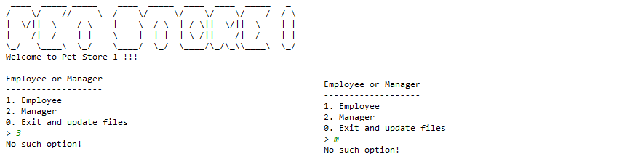

Enter invalid number or alphabet will display an error message “No such option!” to the user.

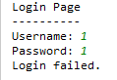

Enter invalid username or password in login page will display a “Login Failed.” message to the user.

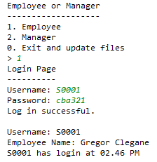

This is the example of entering valid username and password and it will display “Log in successful.” when the user enter correct username and password. It will also display the username, name of the user and the login time once the user has login.

**3.1.2 Menu Options**

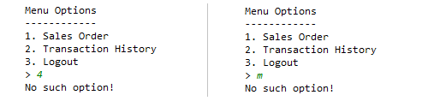

In the menu options, invalid input such as invalid number or alphabet is not available and if the user enter a invalid input the system will display an error message to the user and display again the menu options to the user.

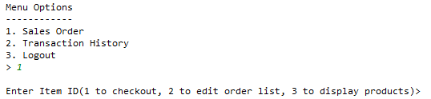

This is the example of entering the valid input.

**3.1.3 Sales Order**

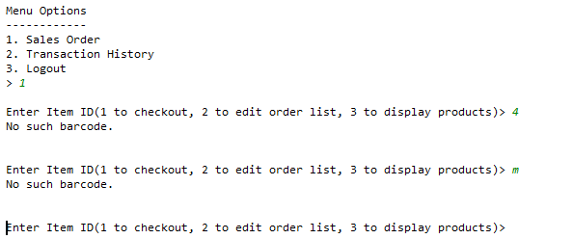

Invalid input such as invalid number and alphabet shown in the picture is not available and will display error message such as “No such barcode.” and will repeat until the user enter valid input.

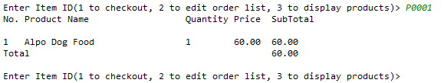

User can enter the item ID such as P0001 to purchase the item as the picture shown.

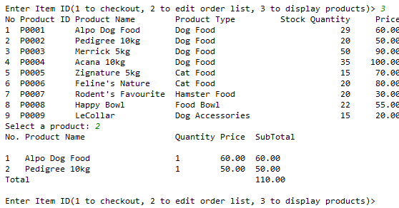

User can enter the number 3 to display the products list and enter the number of the product to purchase the item as the picture shown.

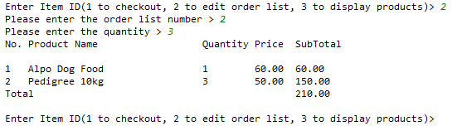

User can modify the quantity of item ordered by entering the number 2, then it will prompt user to enter the number of quantity the user want to modify.

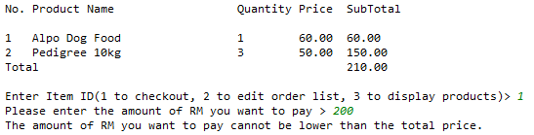

User can enter the number 1 to checkout, If the user enter the amount of RM to pay is less then the total amount ordered, it will display an error message to the user such as the picture shown.

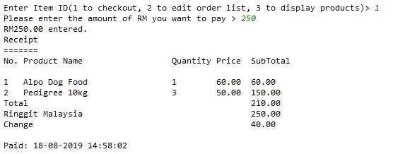

If the user enter the amount of RM to pay is equal to or more than the total amount ordered, it will generate and display the receipt and will have change if the amount of customer paid is more than the total amount ordered such as two of the pictures shown. It will also display the date and time when the receipt is generated

**3.1.4 Transaction History**

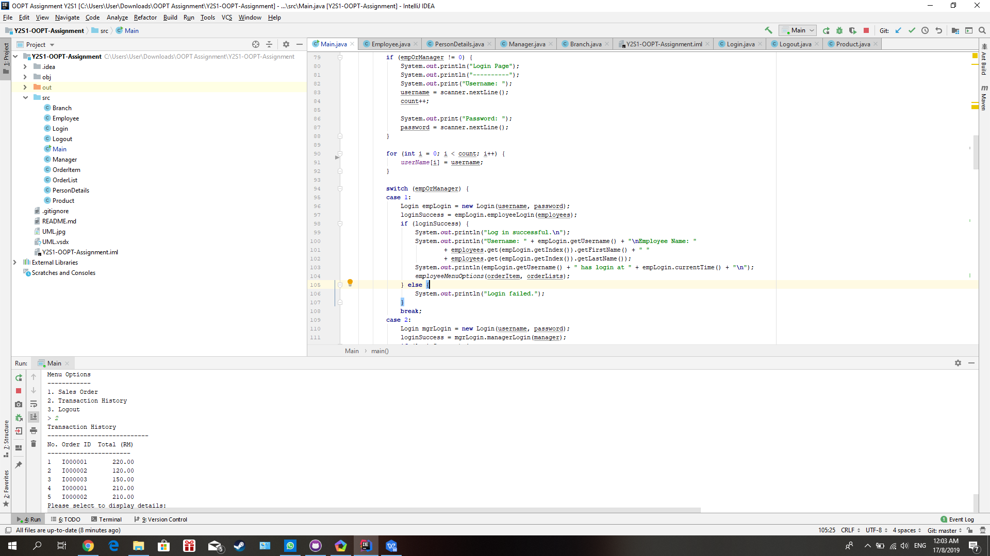

User can enter the number 2 in the menu options to check the transaction history.

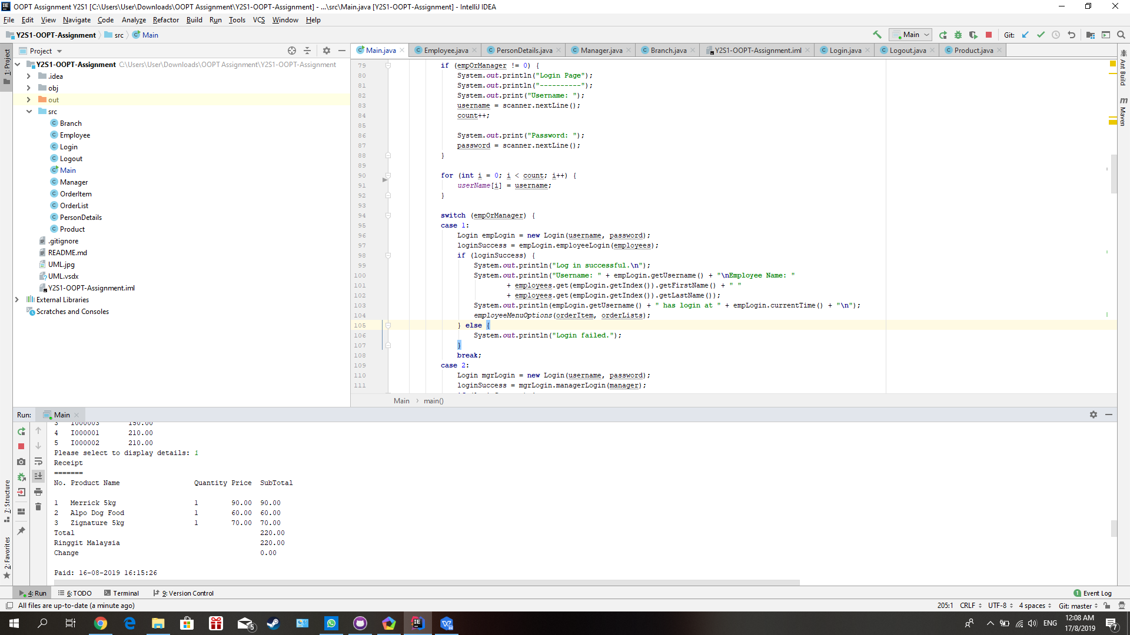

User can check the transaction history by entering valid input such as the number of 1 to 5 as the picture shown. It will display the transaction history to the user based on the number of the user enter.

**3.1.5 Logout**

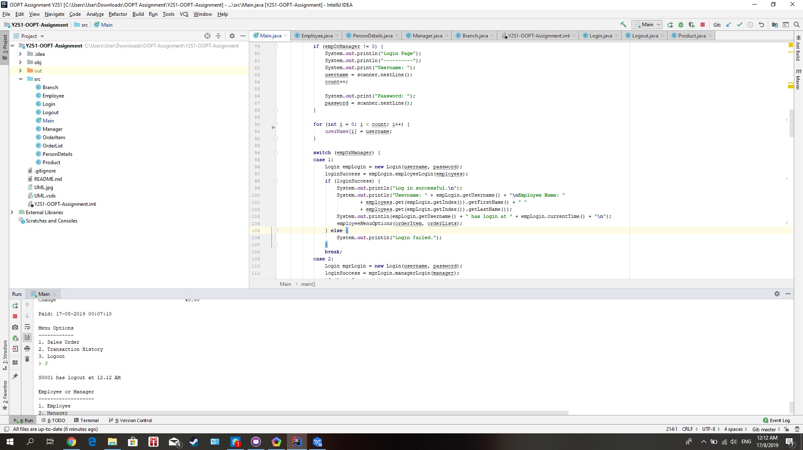

User can logout by entering the number of 3 in the menu options. When the user has logged out, it will display the time of user logout.

**3.2 Manager**

First at all u need choose which position are you being in company option 1 is employee option 2 is manager and option 0 is logout and it u update all the data into binary file. Cannot insert alphabet or invalid option in the choice to log in screen if enter the invalid option it will display an error message such as no such option.

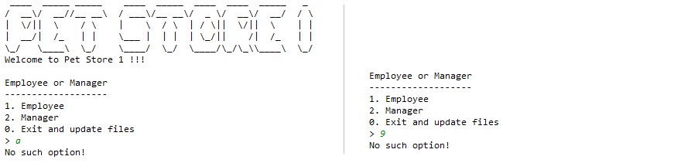

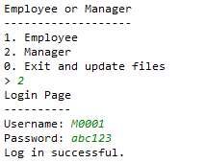

**3.2.1 Login page**

After select option 2 it will go in to the manager login page and the prompt user key in the username and user password and the program will compare the user name and password in the manager file. If the user name and password cannot find in manager file it will go back to the select position page. If success login to manager page it will display a manager option.

**3.2.2 Manager menu page**

At the manager menu page, it will be allowed manager key in value 1 until 4. Option 1 is Add or edit product details. Option 2 is Add or edit employee details. Option 3 is Daily report and option 4 is logout and update all the data into binary file. If key in the valid option the system will display an error message such as no such option and it will require user key in another option can exist.

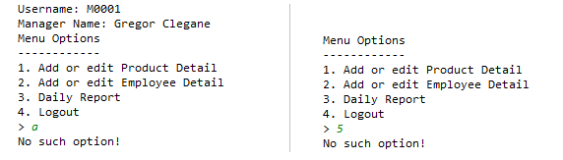

**3.2.3 Add or edit product details**

If user enter the invalid format of product such as 123, abc. It will display an error message “Not a valid product ID”. The right format start with character P and 4digit value. If the enter the product ID is not exit in the product file the system will asking user to add a new product in to our product category. After that, the system required user insert the product detail such as product name, product type, stock and sold price. After that it will require a user to confirm add a new product if press Y the product will add into the product category if press N it will cancel to add new product.

**3.2.4 Edit product**

If enter the product ID is already exist in the product file it will display info about the product and asking the user to edit product option 1 is edit product name. Option 2 is edit product type. Option 3 is edit stock quantity. Option 4 is the edit price of product. If other option it will display an error message. After edit it will require the user to confirm editing a data press Y to change press N to cancel.

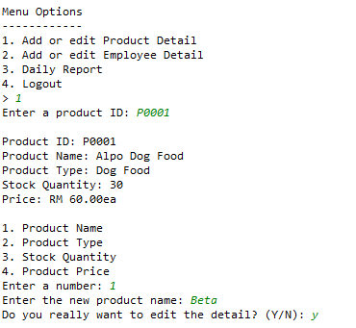

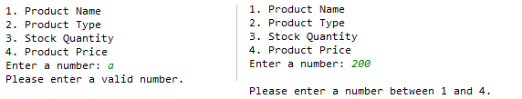

**3.2.5 Add or edit employee**

If enter the staff ID is does not exist in the employee file system will asking the manager insert the new value of the employee. After that it will require the manager to key in the employee info and pay extra attention is email it have a format @. If not, the system will display an error message like “Please enter a valid email ([address@domain.com](mailto:address@domain.com))”. Lastly it will require the manager press y for confirmation to add new employee or press n for confirmation to cancel.

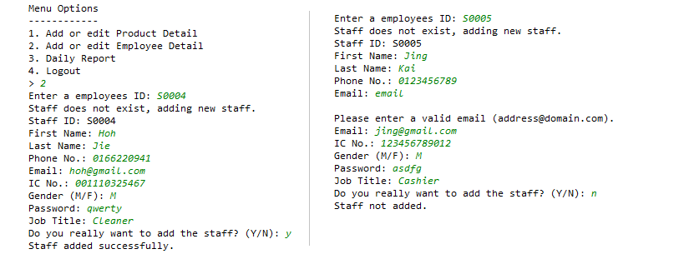

**3.2.6 Edit employee**

If the employee ID is already existing in the employee file it will asking user to edit the employee info such as password, first name, last name, gender, phone number and email. After edit the employee info system also will asking press y to confirmation to change and press n to cancel.

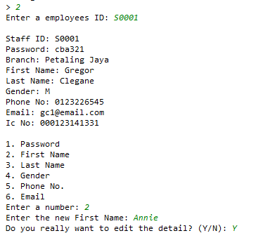

**3.2.7 Daily report**

Finally, option 3 is display the daily sales report for the manager. It shows the stock quantity, sold quantity and total amount for the products that have been sold on the day.

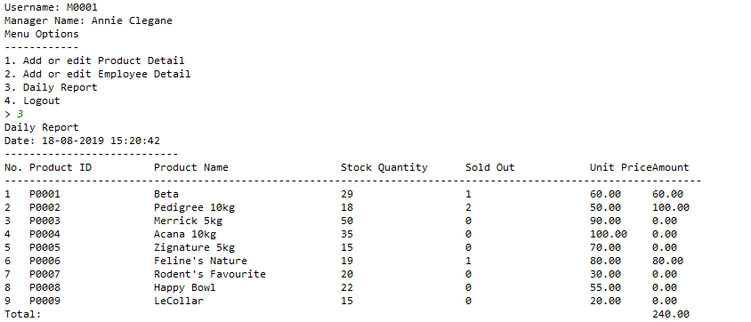

**3.2.8 Logout**

After that press 4 to logout and press 0 to exit and update all the changing in to the binary file.

